MACHINE LEARNING

**Q1 to Q15 are subjective answer type questions, Answer them briefly**.

1.R-squared or Residual Sum of Squares (RSS) which one of these two is a better measure of goodness of fit model in regression and why?

Ans:-  RSS is ideal in any model since it means there's less variation in the data set. In other words, the lower the sum of squared residuals, the better the regression model is at explaining the data.

2.What are TSS (Total Sum of Squares), ESS (Explained Sum of Squares) and RSS (Residual Sum of Squares) in regression. Also mention the equation relating these three metrics with each other.

#### Ans:- TSS(Total Sum of Squares): The total sum of squares is a variation of the values of a [dependent variabl**e**](https://corporatefinanceinstitute.com/resources/knowledge/terms/dependent-variable/) from the sample mean of the dependent variable. Essentially, the total sum of squares quantifies the total variation in a [sample](http://www.webmath.com/sampledata.html). It can be determined using the following formula:

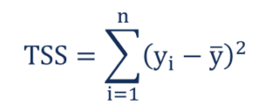

Where:

* yi– the value in a sample
* ȳ – the mean value of a sample

RSS(Residual Sum of Squares):- The residual sum of squares (RSS) is a statistical technique used to measure the amount of [variance](https://www.investopedia.com/terms/v/variance.asp) in a data set that is not explained by a regression model itself. Instead, it estimates the variance in the residuals, or [error term](https://www.investopedia.com/terms/e/errorterm.asp).

RSS = **∑**ni=1(yi - f(xi))2

Where:

yi = the ith value of the variable to be predicted

f(xi) = predicted value of yi

n = upper limit of summation

ESS(Explained Sum of Squares):- Explained sum of square (ESS) or Regression sum of squares or Model sum of squares is a statistical quantity used in modeling of a process. ESS gives an estimate of how well a model explains the observed data for the process.



The ESS is then: where. the value estimated by the regression line . In some cases (see below): total sum of squares (TSS) = explained sum of squares (ESS) + residual sum of squares (RSS).

3.What is the need of regularization in machine learning?

Ans;- Regularization refers to techniques that are used to calibrate machine learning models in order to minimize the adjusted loss function and prevent overfitting or underfitting. Using Regularization, we can fit our machine learning model appropriately on a given test set and hence reduce the errors in it.

4.What is Gini–impurity index?

Ans:- Gini Index, also known as Gini impurity**, calculates the amount of probability of a specific feature that is classified incorrectly when selected randomly.**If all the elements are linked with a single class then it can be called pure.

The Gini Index is determined by deducting the sum of squared of probabilities of each class from one, mathematically, Gini Index can be expressed as:

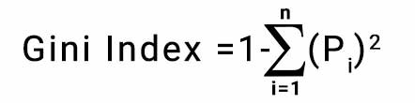

**Gini Index Formula**

Where Pi denotes the probability of an element being classified for a distinct class.

5.Are unregularized decision-trees prone to overfitting? If yes, why?

Ans:- Decision trees are prone to overfitting, especially when a tree is particularly deep. This is due to the amount of specificity we look at leading to smaller sample of events that meet the previous assumptions. This small sample could lead to unsound conclusions.

6.What is an ensemble technique in machine learning?

Ans:- Ensemble learning helps improve machine learning results by combining several models. This approach allows the production of better predictive performance compared to a single model. Basic idea is to learn a set of classifiers (experts) and to allow them to vote.

There are three types of boosting

1. Bagging
2. Boosting
3. Stacking

7.What is the difference between Bagging and Boosting techniques?

Ans:- **Bagging**: It is a homogeneous weak learners’ model that learns from each other independently in parallel and combines them for determining the model average.

**Boosting**: It is also a homogeneous weak learners’ model but works differently from Bagging. In this model, learners learn sequentially and adaptively to improve model predictions of a learning algorithm.

8.What is out-of-bag error in random forests?

Ans**:-** The out-of-bag (OOB) error is the average error for each calculated using predictions from the trees that do not contain in their respective bootstrap sample. This allows the Random Forest Classifier to be fit and validated whilst being trained .

9.What is K-fold cross-validation?

Ans:- K-fold Cross-Validation is when the dataset is split into a K number of folds and is used to evaluate the model's ability when given new data. K refers to the number of groups the data sample is split into. For example, if you see that the k-value is 5, we can call this a 5-fold cross-validation. Each fold is used as a testing set at one point in the process.

**K-fold Cross-Validation Process:**

1.Choose your k-value

2.Split the dataset into the number of k folds.

3.Start off with using your k-1 fold as the test dataset and the remaining folds as the training dataset 4.the model on the training dataset and validate it on the test dataset

5.Save the validation score

6.Repeat steps 3 – 5, but changing the value of your k test dataset. So we chose k-1 as our test dataset for the first round, we then move onto k-2 as the test dataset for the next round.

7.By the end of it you would have validated the model on every fold that you have.

8.Average the results that were produced in step 5 to summarize the skill of the model.

10.What is hyper parameter tuning in machine learning and why it is done?

Ans:- Hyperparameter tuning consists of finding a set of optimal hyperparameter values for a learning algorithm while applying this optimized algorithm to any data set. That combination of hyperparameters maximizes the model's performance, minimizing a predefined loss function to produce better results with fewer errors

11.What issues can occur if we have a large learning rate in Gradient Descent?

Ans:- In order for Gradient Descent to work, we must set the learning rate to an appropriate value. This parameter determines how fast or slow we will move towards the optimal weights. If the learning rate is very large we will skip the optimal solution

12.Can we use Logistic Regression for classification of Non-Linear Data? If not, why?

Ans:-Logistic regression is neither linear nor is it a classifier. The idea of a "decision boundary" has little to do with logistic regression, which is instead a direct probability estimation method that separates predictions from decision.

13.Differentiate between Adaboost and Gradient Boosting.

Ans:- AdaBoost is the first designed boosting algorithm with a particular loss function. On the other hand, Gradient Boosting is a generic algorithm that assists in searching the approximate solutions to the additive modelling problem. This makes Gradient Boosting more flexible than AdaBoost.

14.What is bias-variance trade off in machine learning?

Ans:- **Bias:-**Bias is the difference between the average prediction of our model and the correct value which we are trying to predict. Model with high bias pays very little attention to the training data and oversimplifies the model. It always leads to high error on training and test data.

**Variance:-**Variance is the variability of model prediction for a given data point or a value which tells us spread of our data. Model with high variance pays a lot of attention to training data and does not generalize on the data which it hasn’t seen before. As a result, such models perform very well on training data but has high error rates on test data.

**Bias and variance using bulls-eye diagram**

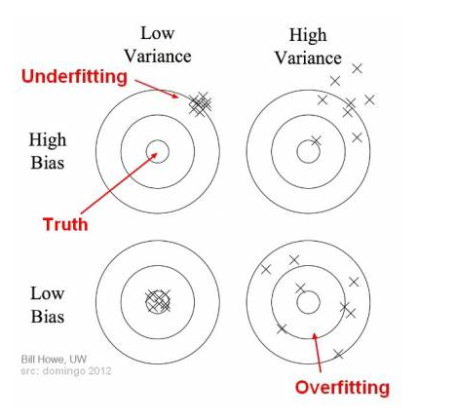

15.Give short description each of Linear, RBF, Polynomial kernels used in SVM.

Ans:- **Linear:-** Linear Kernel is used when the data is Linearly separable, that is, it can be separated using a single Line. It is one of the most common kernels to be used. It is mostly used when there are a Large number of Features in a particular Data Set.

**RBF:-** The RBF kernel works by mapping the data into a high-dimensional space by finding the dot products and squares of all the features in the dataset and then performing the classification using the basic idea of Linear SVM

**Polynomial:-**  The polynomial kernel is a kernel function commonly used with support vector machines (SVMs) and other kernelized models, that represents the similarity of vectors (training samples) in a feature space over polynomials of the original variables, allowing learning of non-linear models